- Untie one end of your deck line. Thread the deck line through small hole created by the loop in the end of the long tape. Re-attach & re-tie the deckline.

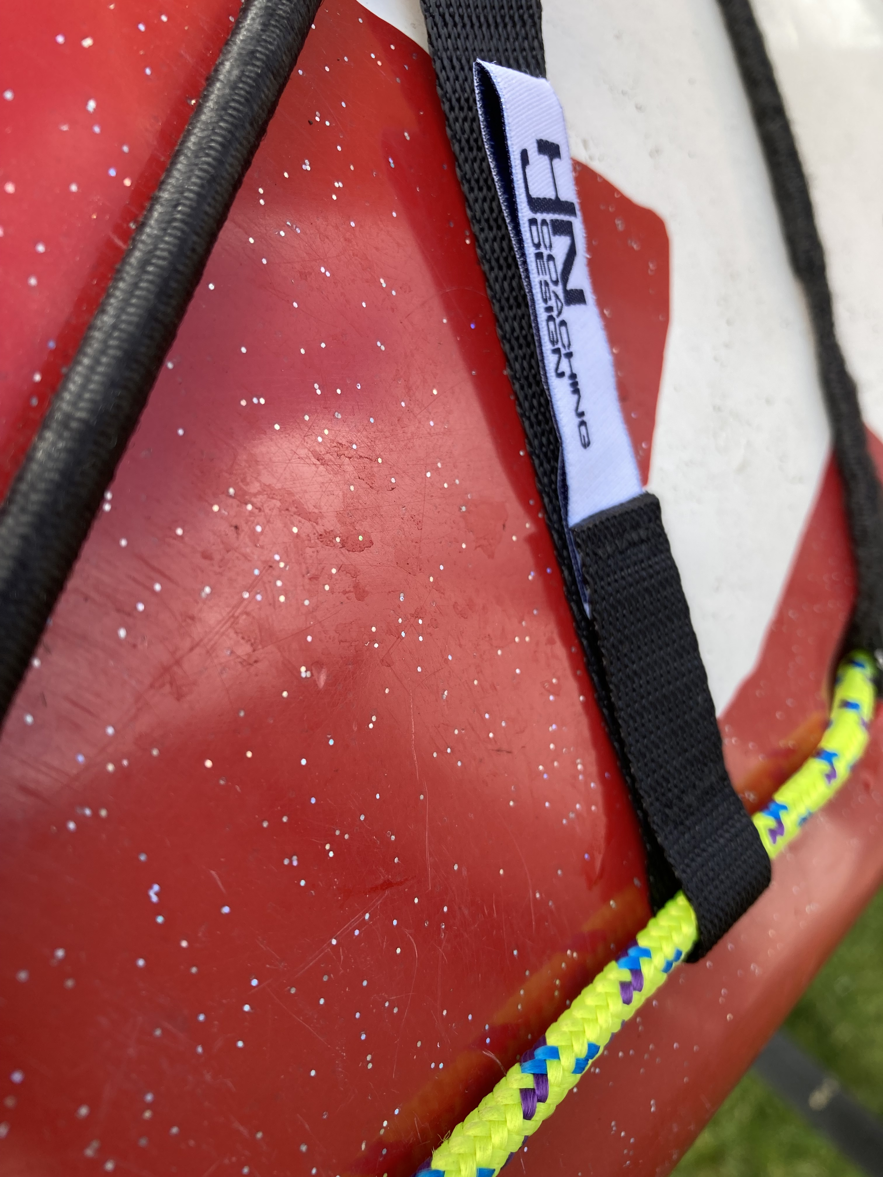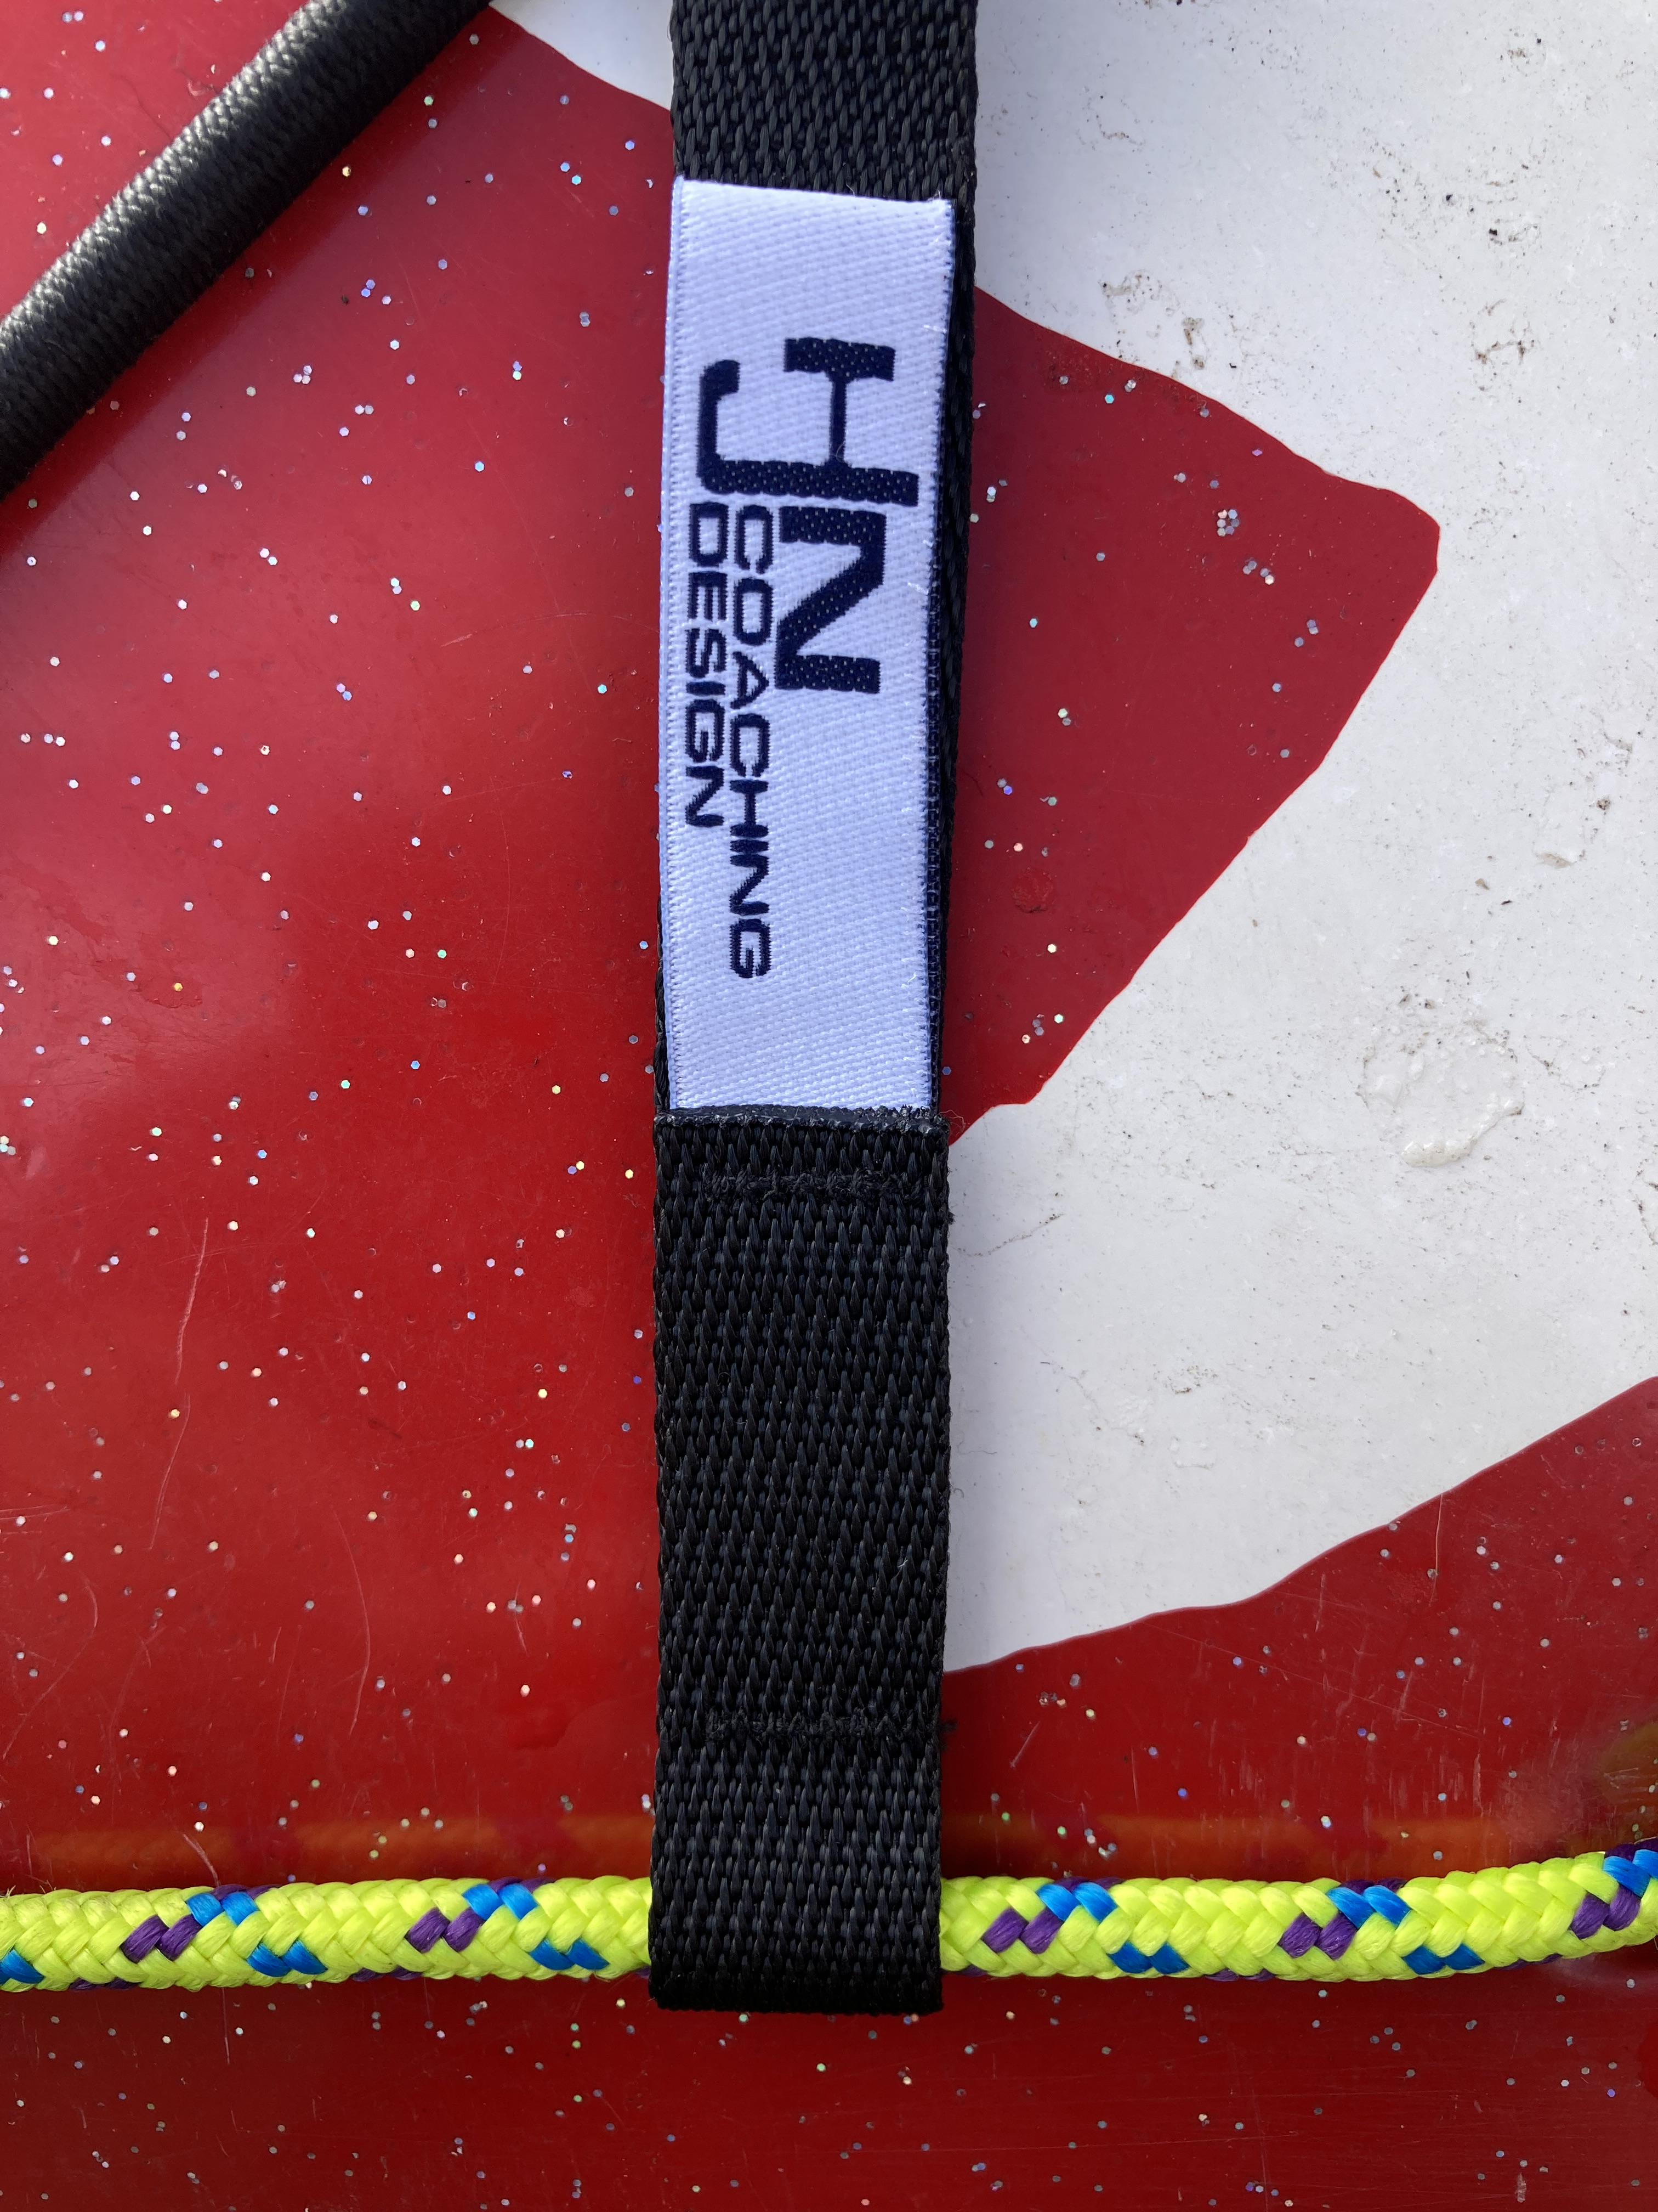

2. Thread the free end of the long tape around the opposite deck line & back through the buckle.

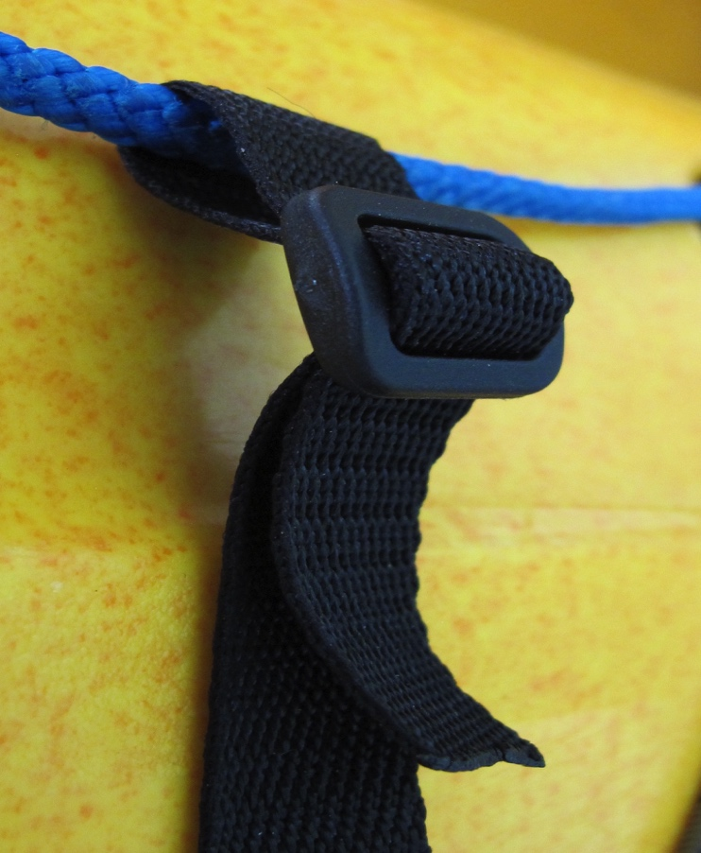
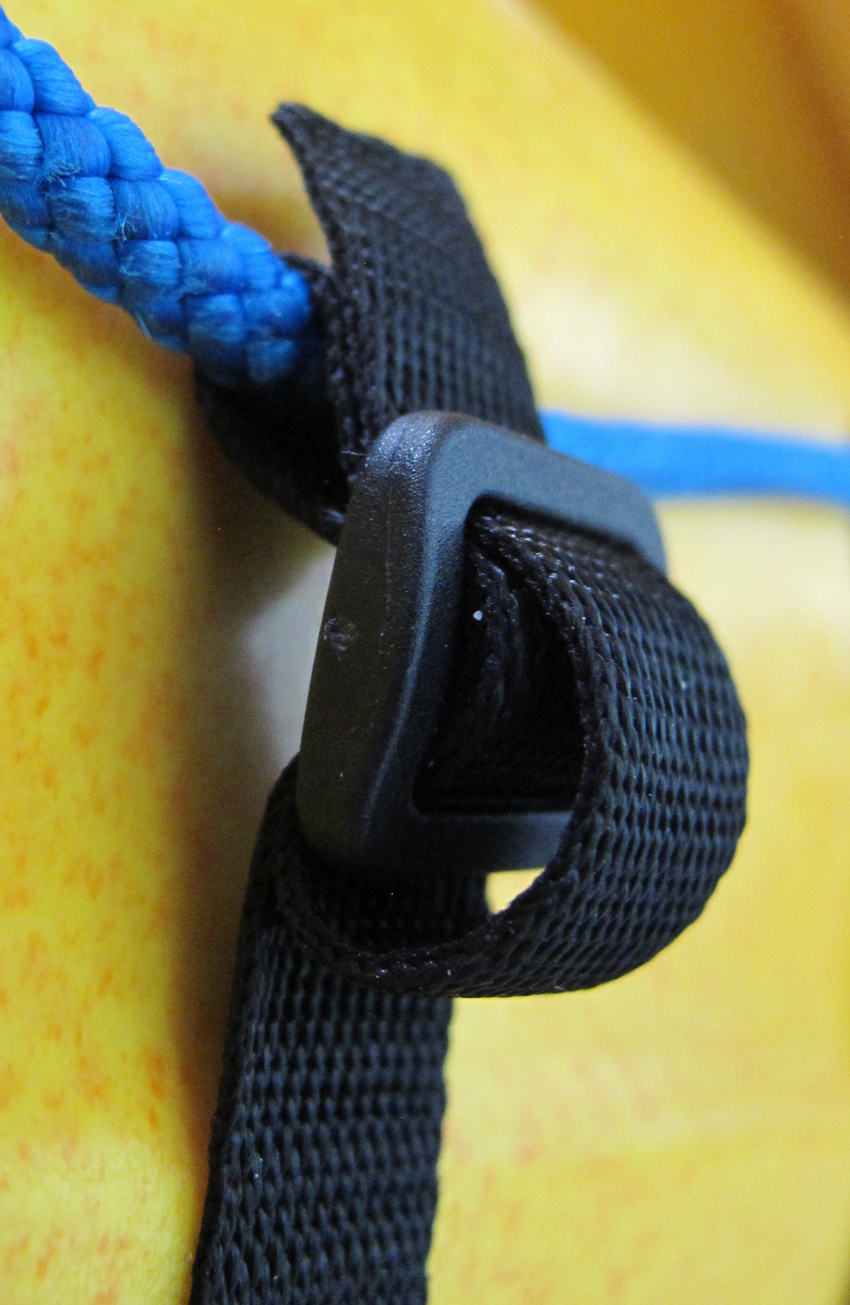

3. Adjust the tape so it lays flat on the deck, then re-thread the loose end back through on it’s self to “lock it off”, trim to length.

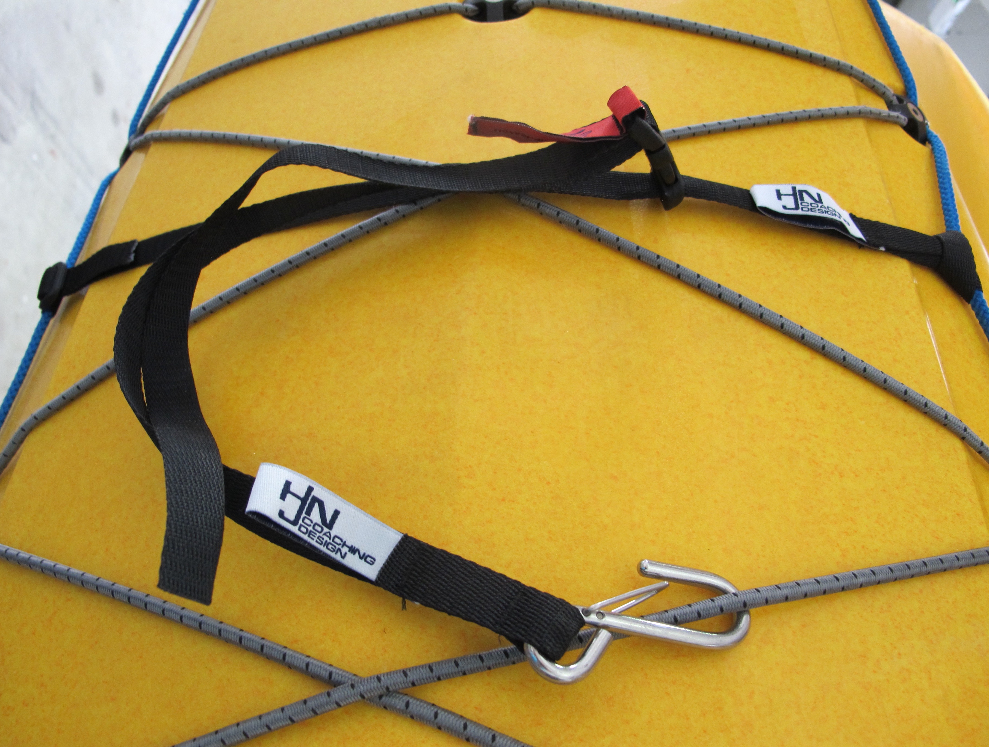

4. Clip the male end of the Paddle Park buckle into the female part of the Cross Strap buckle.

